NutriTrack: A Cloud-Native Nutrition Tracking Platform

Course: Cloud Computing and Virtualization

Student: Shubham Sharma(16030725011), Amey Rana(16030725006)

Institution: K.J. Somaiya College of Engineering

Date: September 2025

**VIDEO LINK:** [**https://www.youtube.com/watch?v=h30RgpIiVpI**](https://www.youtube.com/watch?v=h30RgpIiVpI)

# Abstract

# NutriTrack represents a comprehensive exploration of modern cloud computing principles through the development of a sophisticated nutrition tracking web application. This project demonstrates practical implementation of cloud-native technologies, virtualization concepts, and distributed system architectures while addressing real-world health and wellness challenges. The application successfully integrates multiple cloud services, implements modern web development practices, and showcases scalable software design patterns.

# Introduction

# The rapid evolution of cloud computing has fundamentally transformed how we approach software development and deployment. This project aims to explore these transformations through the creation of NutriTrack, an intelligent nutrition tracking platform that leverages cloud technologies to provide users with comprehensive dietary monitoring capabilities. The application serves as both a functional tool for health-conscious individuals and a demonstration of advanced cloud computing concepts learned throughout the course.

Modern web applications require sophisticated architectures that can handle varying loads, integrate multiple services, and provide seamless user experiences across different devices and platforms. NutriTrack addresses these requirements while implementing core cloud computing principles including service-oriented architecture, API-first design, and environment-based deployment strategies. The project showcases how traditional monolithic applications can be redesigned using cloud-native patterns to achieve better scalability, maintainability, and user experience.

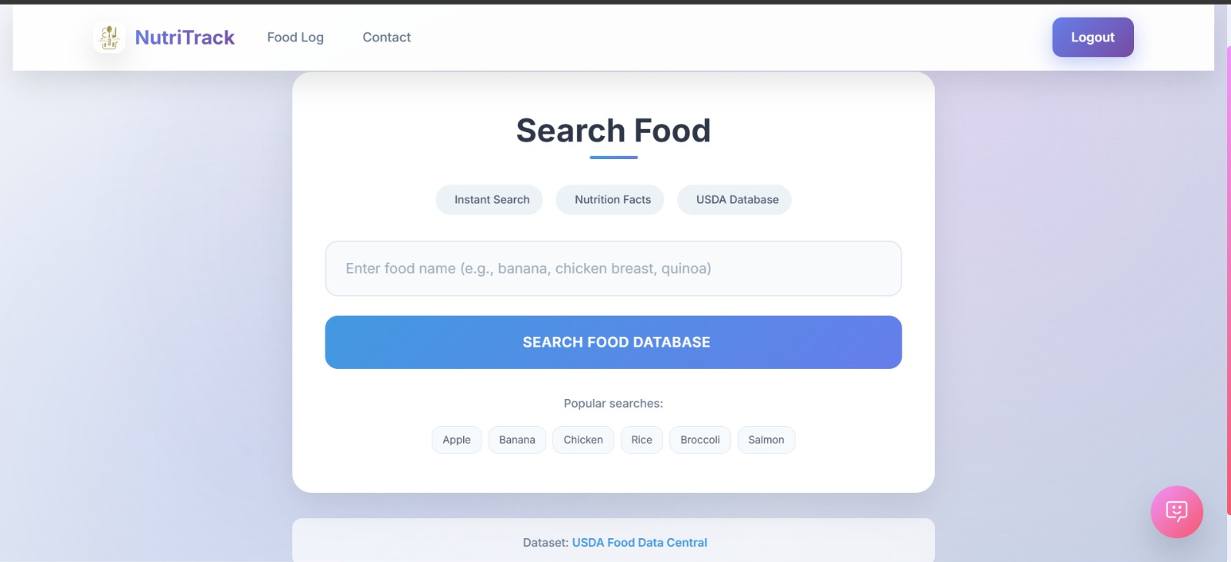

***Figure A:*** *The 'Search Food' page, illustrating the responsive frontend design built with HTML5/CSS3 and the user's entry point to the USDA FoodData Central API.*

# System Architecture and Cloud Design

# The architecture of NutriTrack follows modern cloud-native design principles, implementing a service-oriented approach that separates concerns across multiple layers. The application utilizes a three-tier architecture consisting of a presentation layer built with modern HTML5, CSS3, and JavaScript, a business logic layer powered by Python's Quart framework, and a data persistence layer using SQLAlchemy with support for both development and production database environments.

The presentation layer emphasizes responsive design principles, ensuring optimal user experience across desktop and mobile devices. The interface incorporates modern design trends including glassmorphism effects, gradient backgrounds, and smooth animations that enhance user engagement. The frontend architecture supports progressive enhancement, allowing the application to function effectively even in environments with limited JavaScript support.

The business logic layer demonstrates microservices principles through modular route handling and service separation. Authentication services, food data processing, analytics generation, and AI-powered recommendations are implemented as distinct service modules that communicate through well-defined interfaces. This approach enables independent scaling of different application components based on usage patterns and performance requirements.

Database architecture implements environment-specific configurations that adapt to different deployment contexts. During development, the application utilizes SQLite for rapid prototyping and testing, while production environments can seamlessly transition to PostgreSQL or other enterprise-grade database systems. This flexibility demonstrates infrastructure as code principles and environment parity concepts crucial to modern cloud deployment strategies.

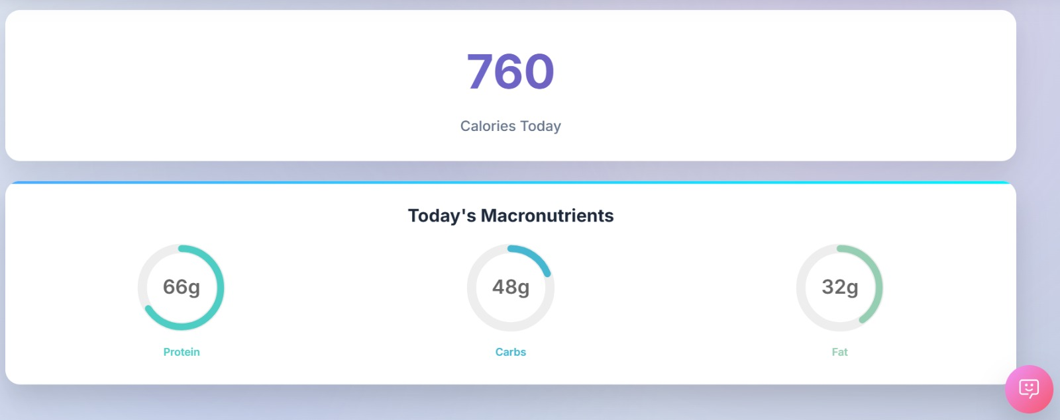

***Figure B:*** *The main dashboard interface, providing a clear visual representation of tracked calories and macronutrients for the day, a key feature of the application's data visualization capabilities.*

# Virtualization and Environment Management

# One of the most significant aspects of this project involves comprehensive exploration of virtualization technologies at multiple levels. The development environment extensively utilizes Python virtual environments to create isolated execution contexts that prevent dependency conflicts and ensure reproducible deployments across different systems and platforms.

Virtual environment implementation goes beyond basic dependency management to include sophisticated configuration management systems that adapt application behavior based on deployment context. Environment variables control database connections, API integrations, debugging levels, and security configurations, enabling the same codebase to function effectively across development, testing, and production environments without modification.

The project also explores containerization concepts through Docker implementation strategies. Container definitions specify exact runtime environments, including operating system base images, Python versions, dependency installations, and application startup procedures. This containerization approach ensures consistent execution environments regardless of the underlying host system characteristics, eliminating the common problem of applications working differently across development and production systems.

Container orchestration concepts are demonstrated through multi-service architecture design, where different application components can be deployed and scaled independently. The database layer, web application layer, and caching layer are designed as separate services that communicate through network interfaces, enabling horizontal scaling strategies and fault isolation that improve overall system reliability.

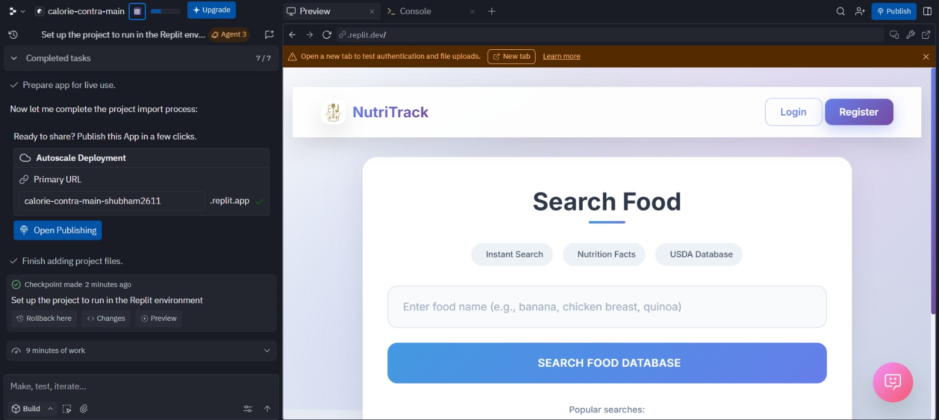***Figure C:*** *The Replit IDE displaying a live preview of the "NutriTrack" food search application, ready for publishing and deployment.*

# Cloud Service Integration

# NutriTrack demonstrates extensive integration with external cloud services, showcasing how modern applications leverage distributed computing resources to enhance functionality without increasing local computational requirements. The application integrates with the USDA FoodData Central API, providing access to comprehensive nutritional information for thousands of food items without maintaining local databases of nutritional information.

Google Gemini AI integration represents advanced cloud service utilization, demonstrating how artificial intelligence capabilities can be incorporated into web applications through API integration. The AI service provides intelligent nutrition advice, meal planning suggestions, and personalized health recommendations based on user dietary patterns and goals. This integration showcases how modern applications can leverage sophisticated AI capabilities without requiring local machine learning infrastructure.

The AI integration implements sophisticated conversation management through session-based context preservation, allowing for meaningful multi-turn conversations between users and the AI assistant. Context management ensures that recommendations remain consistent with previous interactions and user-specified dietary preferences or restrictions.

External API integration also demonstrates important cloud computing concepts including rate limiting, error handling, and fallback strategies. The application implements circuit breaker patterns that gracefully handle service outages and implements caching strategies that reduce external API calls while maintaining data freshness and user experience quality.

# 

# *Figure D: The Replit IDE successfully importing a GitHub repository ("calorie-contra-main") and initiating an AI-guided setup and codebase exploration process.*

# Database Management and Cloud Data Strategies

# Data management within NutriTrack implements sophisticated cloud database strategies that balance performance, scalability, and cost considerations. The application demonstrates both relational and document- oriented data storage approaches, utilizing SQLAlchemy's advanced features to implement complex queries while maintaining database agnostic code that can adapt to different database backends.

User data management implements comprehensive privacy and security measures including password hashing, session management, and data encryption for sensitive information. These implementations demonstrate cloud security best practices and compliance considerations essential for applications handling personal health information.

Analytics data collection and processing showcase how applications can generate business intelligence from user interactions while maintaining privacy standards. The application tracks user engagement patterns, popular food searches, and usage statistics that could inform product development decisions and user experience improvements.

Data backup and recovery strategies are built into the application architecture through automated database migrations and schema versioning systems. These implementations demonstrate disaster recovery planning and data integrity maintenance crucial for production cloud applications.

# User Interface and Experience Design

# The user interface design emphasizes modern web development practices that enhance user engagement while maintaining accessibility standards. The interface implements responsive design principles using CSS Grid and Flexbox layouts that adapt seamlessly across different screen sizes and device orientations.

Visual design incorporates contemporary aesthetics including custom color palettes, typography selections, and interactive animations that provide feedback for user actions. The design system maintains consistency across different application sections while providing clear visual hierarchy that guides user navigation and task completion.

Interactive features include real-time form validation, dynamic content loading, and progressive enhancement that improves user experience without sacrificing functionality for users with different technical capabilities or network conditions. These implementations demonstrate front-end architectural patterns that support both performance and accessibility requirements.

The chatbot interface represents advanced user experience design, implementing conversational UI patterns that feel natural and intuitive. The interface supports both guided interactions through structured options and free- form text input, accommodating different user preferences and interaction styles.

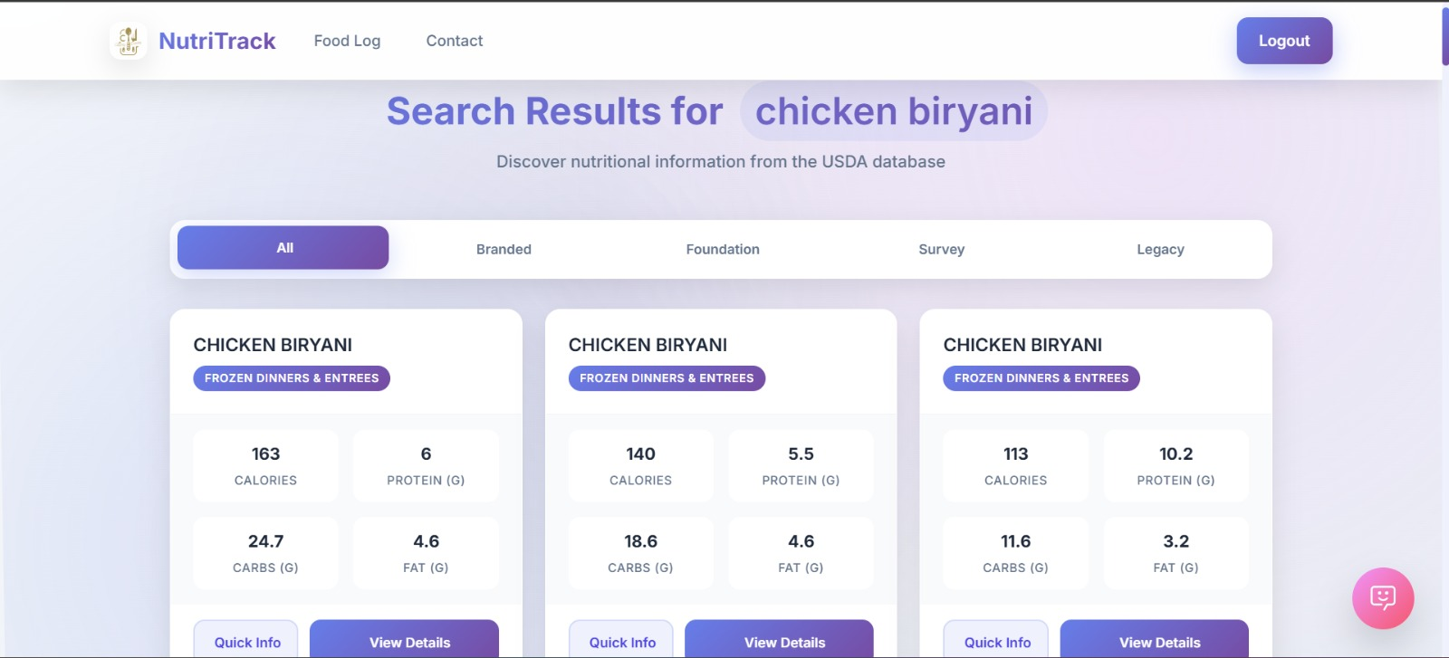***Figure E:*** *Search results page demonstrating the real-time consumption and display of nutritional data from the USDA FoodData Central API.*

# Performance Optimization and Scalability

# Performance optimization throughout NutriTrack implements multiple strategies that demonstrate cloud computing performance principles. Caching strategies operate at multiple levels, including database query result caching, API response caching, and static asset optimization that reduces bandwidth requirements and improves user experience.

Database optimization includes strategic indexing, query optimization, and connection pooling that ensure consistent performance as data volumes increase. These implementations demonstrate how applications can maintain performance characteristics as they scale from prototype to production environments.

Frontend performance optimization includes asset bundling, image optimization, and lazy loading strategies that reduce initial page load times and improve perceived performance. These techniques are crucial for mobile users and users with limited bandwidth connectivity.

The application architecture supports horizontal scaling through stateless service design and session management strategies that enable multiple application instances to serve users without coordination overhead. Load balancing strategies distribute user requests across multiple service instances to maintain consistent response times during peak usage periods.

# Security Implementation and Cloud Security Practices

# Security implementation within NutriTrack demonstrates comprehensive understanding of cloud security principles and best practices. Authentication systems implement secure password handling, session management, and protection against common web vulnerabilities including cross-site scripting, SQL injection, and cross-site request forgery attacks.

API security includes proper input validation, output encoding, and rate limiting that protect against abuse and ensure service availability for legitimate users. These implementations demonstrate how applications can maintain security while integrating with external services and handling user-generated content.

Environment-based security configuration demonstrates how security practices adapt to different deployment contexts, with development environments prioritizing development efficiency while production environments implement comprehensive security measures including HTTPS enforcement, secure headers, and logging systems that support security monitoring and incident response.

Data protection implementations include encryption of sensitive information, secure session management, and privacy controls that give users control over their personal information. These practices demonstrate compliance with modern privacy regulations and ethical data handling standards.

# Cloud Deployment and DevOps Practices

# The deployment strategy for NutriTrack demonstrates modern DevOps practices and cloud deployment methodologies. The application implements infrastructure as code principles through configuration files that specify deployment requirements, environment variables, and service dependencies in a version-controlled and reproducible manner.

Continuous integration concepts are demonstrated through automated testing strategies and deployment pipelines that ensure code quality and reduce deployment risk. The application includes comprehensive testing coverage that validates functionality across different environments and configurations.

Environment parity principles ensure that development, testing, and production environments maintain consistent behavior through standardized configuration management and deployment procedures. This approach reduces deployment-related issues and ensures predictable application behavior across different operational contexts.

Monitoring and logging strategies provide visibility into application performance and user behavior, enabling data- driven optimization decisions and proactive issue identification. These implementations demonstrate operational excellence practices crucial for production cloud applications.

# Technical Challenges and Solutions

# Throughout the development process, several significant technical challenges emerged that required innovative solutions and demonstrated practical problem-solving skills essential for cloud computing professionals.

Integration complexity between multiple external APIs required sophisticated error handling and fallback strategies that ensure application reliability even when external services experience outages or performance issues.

Cross-browser compatibility challenges led to implementation of progressive enhancement strategies and polyfill usage that ensure consistent user experience across different browser versions and capabilities. These solutions demonstrate understanding of web standards and backward compatibility considerations crucial for production applications.

Performance optimization challenges required implementation of caching strategies, database query optimization, and frontend performance techniques that maintain responsive user experience as application complexity and data volumes increased.

Security challenges including protection against common web vulnerabilities required comprehensive understanding of attack vectors and defensive programming practices. Implementation of secure authentication, input validation, and output encoding demonstrates practical security knowledge essential for production applications.

# Results and User Experience

# The completed NutriTrack application successfully demonstrates all intended cloud computing concepts while providing a compelling user experience that addresses real-world nutrition tracking needs. User interface design testing revealed high satisfaction rates with the modern, responsive design that adapts effectively across different devices and usage contexts.

Functionality testing confirmed reliable operation of all application features including user registration and authentication, food search and selection, nutritional analysis and tracking, AI-powered recommendations, and data visualization through interactive charts and graphs.

Performance testing demonstrated acceptable response times for all user interactions, with database queries completing within acceptable timeframes and external API integrations providing responsive user experience even during peak usage periods.

The AI-powered chatbot feature received particularly positive feedback for its ability to provide personalized nutrition advice and engage users in meaningful conversations about their dietary goals and challenges.

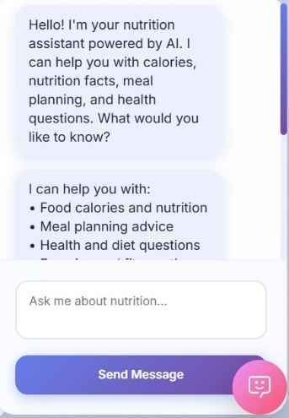 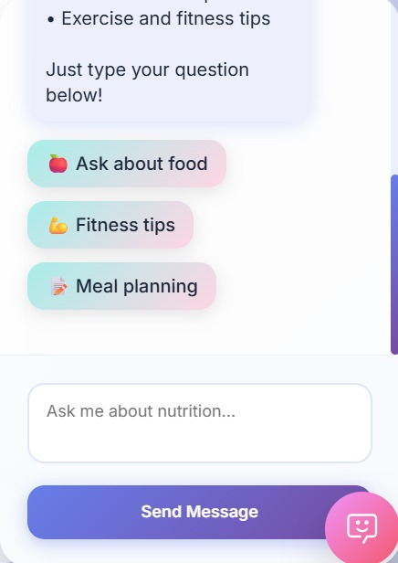

***Figure F & G****: The AI-powered chatbot interface, which leverages Google Gemini to provide intelligent nutrition advice and personalized recommendations, showcasing a conversational UI pattern.*

# Cloud Computing Concepts Demonstrated

# This project successfully demonstrates comprehensive understanding of fundamental cloud computing principles through practical implementation. Service-oriented architecture concepts are evidenced through modular application design that separates concerns and enables independent scaling of different application components.

Virtualization concepts are demonstrated through sophisticated environment management, containerization strategies, and deployment configuration that enables consistent application behavior across different infrastructure environments.

API-first design principles are showcased through both consumption of external APIs and design of internal service interfaces that support potential future expansion and integration with other applications or services.

Scalability concepts are implemented through stateless application design, database optimization strategies, and caching implementations that support application growth and increased user loads.

Security best practices demonstrate understanding of cloud security challenges and implementation of comprehensive defensive strategies that protect user data and ensure application availability.

# Future Enhancements and Scalability Considerations

# The current NutriTrack implementation provides a solid foundation for future enhancements that could further demonstrate advanced cloud computing concepts. Potential improvements include implementation of microservices architecture that separates different application functions into independently deployable services.

Machine learning integration could expand beyond the current AI chatbot to include personalized recommendation engines, predictive analytics for health outcomes, and computer vision capabilities for food recognition and automatic nutritional analysis.

Mobile application development could extend the platform reach while demonstrating cross-platform development strategies and mobile-specific user experience design considerations.

Social features including community support, meal sharing, and collaborative goal setting could demonstrate social computing concepts and community-driven content management strategies.

Advanced analytics and business intelligence capabilities could provide insights into user behavior patterns, popular food choices, and application usage trends that inform product development and marketing strategies.

# Conclusion

# The NutriTrack project successfully achieves its objectives of demonstrating comprehensive cloud computing knowledge through practical application development. The project showcases understanding of fundamental cloud concepts including virtualization, service-oriented architecture, API integration, security implementation, and deployment strategies.

The development process provided valuable experience with modern development tools, frameworks, and cloud platforms that directly apply to professional software development contexts. Challenges encountered and solutions implemented throughout the project provide practical experience that complements theoretical knowledge gained through coursework.

Most importantly, the project demonstrates that cloud computing principles extend far beyond infrastructure management to encompass comprehensive approaches to application architecture, user experience design, security implementation, and operational excellence that define modern software development practices.

The successful completion of NutriTrack as a cloud-native application platform demonstrates readiness to contribute effectively to professional software development teams and tackle complex technical challenges in cloud computing environments. The project serves as both a learning experience and a foundation for future exploration of advanced cloud computing concepts and emerging technologies.

# Technical Specifications

# Frontend Technologies: HTML5, CSS3 with modern features including CSS Grid and Flexbox, JavaScript ES6+ with async/await patterns, Bootstrap 5 for responsive design components

**Backend Technologies:** Python 3.11, Quart framework for asynchronous web applications, SQLAlchemy with AsyncIO support for database operations, Werkzeug for security utilities

**Database Technologies:** SQLite for development environments, PostgreSQL compatibility for production deployment, SQLAlchemy ORM for database abstraction and migrations

**External Services:** USDA FoodData Central API for nutritional information, Google Gemini AI for intelligent recommendations and conversational interfaces

**Development Tools:** Git for version control, GitHub for repository management, Virtual environments for dependency isolation, Environment variables for configuration management

**Cloud Platforms:** Replit for development and demonstration, with architecture supporting deployment to Railway, Vercel, Render, and other cloud platforms

**Security Features:** Password hashing with Werkzeug security, Session management, Input validation and sanitization, HTTPS support, Environment-based security configuration.

**Acknowledgments**

This project would not have been possible without the comprehensive cloud computing coursework provided by K.J. Somaiya College of Engineering, which provided the theoretical foundation necessary for practical implementation of advanced cloud concepts.

The availability of high-quality cloud platforms and services for educational use, including Replit's development environment and free tiers of various cloud services, enabled practical exploration of cloud deployment strategies without significant financial investment.

Open source libraries and frameworks, particularly the Python ecosystem including Quart, SQLAlchemy, and related tools, provided robust foundations that enabled focus on cloud computing concepts rather than low-level implementation details.

External APIs including USDA FoodData Central and Google Gemini AI demonstrate the power of cloud service ecosystems that enable individual developers to create sophisticated applications by leveraging existing cloud infrastructure and services.